**Paulin Newsletter**

**September 2024**

**3200 Woodland Ave. (519) 972-3627**

**Email: office@paulinmemorial.ca**

**Message from Reverend Lisa**

It’s hard to believe that fall is almost upon us. The stores are filled with back-to-school supplies, and soon the smell of pumpkin spice will fill the air, as we slowly move away from our summer mindset to prepare ourselves for somewhat cooler weather. I know that Windsor will have at least a couple more months of hot weather, but for the rest of Canada fall is fast approaching, and I can’t wait. I love the fall season, from the leaves changing colours to the brisk wind that wakes you up in the morning as you head out the door. But what I love the most is how our church seems to come alive during the fall seasons, our choir comes back, after a summer rest, with beautiful anthems, although they have also blessed our worship during the summer months. Many of our members come back after vacations ready to share the stories of their adventures away from Windsor. And our Bible Studies pick up again, as we seek to learn more about the Lord and His plans for the world that He created and called good. Summer tends to be a bit slower of a season in the church, although I am not sure this applies to Paulin, as this summer our church was busy with VBS, Summer BBQs, a trivia night as well as movie nights and our youth group. But for many of us September is the month when things start to go back to normal.

For parents this means sending the kids off to school, even if the kids might not be ready for it, their parents are. And for those of us without children or children who are already finished with school, September can still represent a new beginning for us, just the same as it is for the kids heading off to school.

September is a great time to start new habits, new skills, new disciplines that can help you grow in the coming months in both your personal and your faith life. In September many of our Paulin committee groups will start to meet once more and this is the perfect time for you to think about joining one of them. If you have a passion for worship, that committee is looking for people to join right now, or perhaps you feel called to serve in our community then you might be a great fit for our Faith Community Action group. If you have a gift for hospitality you might want to sign up to serve coffee one Sunday or if you’re feeling brave you might even sign up to read scripture, it is not always filled with long and sometimes hard to pronounce names. You could join up with a bible study or dive deep in the chosen, you could learn to knit a prayer shawl or even volunteer to pray for the members in our congregation. There are countless ways that you can get involved at Paulin and fall is the perfect time to jump in.

We at the church are getting ready for an exciting season of worship and service and we could always use an extra hand or twenty in helping to share God’s good news with the community around us. So this September as you see the signs of the changing of the seasons, take a moment and ask yourself about what changes you could make in your life to grow closer to God and to His beloved people. As together we seek to make our worship and work as one.

Thanks be to God, amen.

Reverend Lisa 

**Camp Kintail**

My Kintail Experience by Scarlett Gagnier

 This summer I was an LIT at Camp Kintail. I’ve wanted to work at Kintail ever since I could remember, as my mom was also a counsellor there. Everyone was so welcoming and friendly! I made friendships for life with so many people. The LIT’s stay in the Nest, which was fun. It was like a nightly sleepover! I also loved learning about how to interact with the campers and the staff. I was able to spend three weeks in cabin working directly with campers, which was an amazing experience. The children were very funny and sweet, and I liked learning how to work with different counsellors. Beach time daily was my favourite part of the day! The kids loved the water, especially pretending to be mermaids. I also really loved leading FLASH, and learning new faith based songs. Kintail is such a beautiful place. I saw so many kinds of wildlife, my favourite being the bunnies. Campfires were the best way to end each perfect day! I am looking forward to applying to be a camp counsellor at Kintail next summer. Thank you to my Paulin Family for supporting my faith learning journey!

Scarlett's Leader in Training Course was partially covered by Paulin.

**Sunday School**

**Ah, the children!** Audrey Landon August 2024.

On Sunday when Rev. Lisa says to the children & “you can go down to Sunday School with Miss Audrey”; something bursts in my heart. What a privilege I have been given; what a blessing the Lord has bestowed upon me to be allowed to spend time with these children. These little souls so innocent, yet so wise, so silly yet so wondering, so young yet so old in their souls.

I can be criticized for not having a detailed curriculum, every lesson mapped out and recorded. A lot of times we just elaborate on what Lisa has told us in the childrens story. Sometimes we do a craft that has nothing to with the story at all. Sometimes we play paper plate frisbee.

I try to impart some scripture but expecting the children to memorize verses is not my thing. They ask questions I often have trouble answering. I am not a scholar.

Long before came to Paulin, I spent time with young children; at times with upward of 60. I doubt any of them remember a thing I said except maybe deep in their hears. Maybe when they are troubled or afraid they remember they are loved and never alone. Maybe when they see a homeless person they will have compassion and remember we are called to love our neighbor.

My being with the children is a joy, a privilege, a blessing. They help me on my faith journey. I want them to leave my classroom knowing Gods love and grace and understanding that we are all his blessed children.

Nothing more, nothing less.

**Faith Community Action Group**

September 30th is National Day for Truth and Reconciliation.  The FCA group is encouraging everyone to wear an Orange shirt on Sunday, September 29th to remind ourselves of the truth that the Presbyterian Church operated Residential Schools in Canada in the past and their negative effects on our Indigenous brothers and sisters.   As we walk a path of reconciliation, let us pray for forgiveness for those actions  and redirection to paths of justice and in ways of love so that in truth we can turn to God.

The FCA group is meeting on Monday, September 9th at 7 pm in the Church parlour to plan community action projects for the fall.  We are looking for new members to help plan and carry out these community support projects.

Anne McLachlan

amclachlan.am@gmail.com

Always Open to Different Perspectives

**Board of Managers Report**

It looks like Jim and his helpers have been busy working around Paulin this summer. They have painted the Norfolk door, painted the cross, installed solar lighting on the cross, renovating ladies washroom, building stage thrust, fixing tunnel leaks, and repaired carillon.

Thank you to the property committee.

**Choir News**

(This is an update on the report I wrote for the spring newsletter, which because of a “distribution

glitch” didn’t reach many people.) The choir has continued to grow in numbers under Heather’s capable leadership, and as we look forward to a new season of leading the music ministry at Paulin this might be a good time to share some facts about who we are. Our church has had a choir since the day the building opened over 60 years ago – and Bonnie has been a member throughout that time! There are currently 12 members: sopranos Yvonne, Ann, Mary Ellen, Margaret, Finn and Kristina; altos Jeanmarie, Janelle, Bonnie, Carolyn and Carol – and one solitary bass, myself! So we continue to welcome new singers in all sections, but a few more men (especially tenors – and some ladies sing tenor) would be a great boost to our ranks. Just like our congregation, we are a very diverse, multigenerational group, ranging from students to retired octogenarians, and we come from a variety of work experiences, health care, education, business, law enforcement and of course home-making. The one thing that binds us together is our love of singing. Some of us have sung in a variety of different choirs – community, symphonic, other churches, and in different countries, - but as members of the Paulin choir we all share the desire to enrich our worship on regular Sunday services and special occasions like Christmas and Easter. We also share in the joys and challenges of each other’s lives and are always there for each other. Sound like a group you would like to be part of? To echo a certain TV ad: “See Heather.”

Respectfully submitted by Norm Diffey

**September at Paulin**

It’s the end of the summer,  
Oh, how we’ve been blessed,  
With sunshine and pools,

And travel and rest.  
  
We had movies and popcorn,  
And trivia, too.  
We had kids’ VBS  
And a duet or two.  
  
We sweltered through Sundays,  
Our mortgage is DONE!  
We gathered for BBQ’s  
Steaks, burgers and buns!  
  
We think that we’re ready,  
Refreshed and restored  
To get our fall rolling  
Before we get bored!  
  
Let’s start up our studies,  
Plan outreaches, too!  
Hold drama rehearsals,  
And the choir’s back, too!  
  
The summer is ending,  
The fall has begun,  
Let’s come back together!  
God bless everyone.

By Kristina Garswood

**Vacation Bible Day Camp**

Camp Firelight ran for four days this year, the first week of August. We had a wonderful time with 14 campers, 4 wonderful highschool volunteers and 6 adults running the various activities. We sang songs, danced and worked on a skit with Miss Heather, did crafts with Miss Audrey, listened to bible stories with Miss Kristina, played games with Reverend Lisa and learned about a mission project, did some science activities and ate snacks prepared by Miss Carla. A special thanks to Jonathan who ran the powerpoint and music for our opening and closing sessions each day. Our Mission Project was Living Gifts and the final total is absolutely amazing. Thanks to our campers and members of the congregation, we received a total of $637.05. With this amount, we will be able to purchase 3 goats, provide 4 families with seeds and all they need for a garden, allow 4 students to have all the school supplies they will need for one year, and then determine with the children how to distribute the remaining amount. Thanks so much to all who contributed. Once again, we had the wonderful Chantal come and do face painting thanks to the generosity of one of our church members, and we had a fun water day. We enjoyed sharing with the congregation on Sunday, August 11th. Thanks to all who assisted, sent their family members or who prayed for a successful week. We had a wonderful time. Stay tuned for information about next year’s VBS.

Respectfully submitted by Carla Hicks

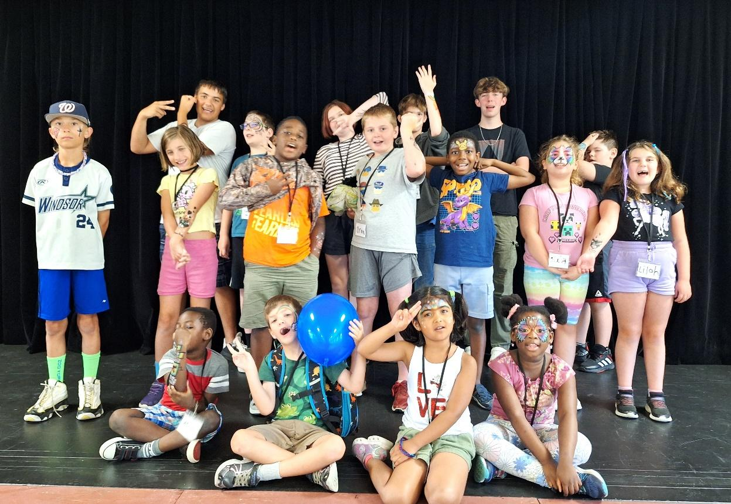

**Movie Nights**

When The Chosen Bible study on Wednesday nights went into a summer hiatus, it was clear that people still wanted an excuse to get together for a little social time in the parlour.  We didn't meet every week, but we did enjoy movie nights together in the Parlour several times this summer.  Turnout has been great, and we've enjoyed some good films together, with popcorn and snacks.  It's always good to get together, and the summer can stretch on in a long way when we don't have the chance, so we were grateful for Congregational Life getting the church movie licence reinstated so we could enjoy some community viewing.  Movie nights will continue once the fall is here - it just won't be as often, and we'll have to find an alternative to Wednesdays, once we get back into the swing of things with Season Two of The Chosen.  Thank you to all who have participated!  PG-13 movie suggestions are always welcome - talk to Kristina or John Garswood with your ideas!

**Youth Group**

Paulin's Youth Group got off to a fun, low-key little start this summer.  Beginning mid-July, we have had a few kids coming out, one, two or three at a time.  Numbers, we have decided, are not the most important thing, when you're starting a youth group after a long time of not having one.  
  
Each week, we prepare a focal Bible verse, at least one game, some discussion points, and usually some music and prayer.  There is always food!    
  
In the photos, you see two young brothers, Myles and Lucas, learning about how God chooses to dwell in jars of clay, as they rebuild a broken jigsaw puzzle vase.  We talked about things we've broken, and times we've felt discouraged by our messy failures and faults, but remembered that God always loves us, forgives us, and lets us start anew.   
  
Our Bible Verse was 2 Corinthians 4:7 - *“But we have this treasure in jars of clay to show that this all-surpassing power is from God and not from us."*We were also reminded of all the heroes of the bible, who each had their own flaws, failures, and challenges! We played a game, and then finished off by enjoying slices of pie that were "too messy! too broken" to serve at the Steak Dinner, that still tasted wonderful.

Broken doesn't have to mean ruined!  We are glad to be able to share the truth of God's loving forgiveness and grace in our lives with the young people in our congregation and our community.  All are welcome - Tuesdays from 6:30-7:30 p.m.  Parents are welcome to stay to have social time together in the Parlour while the kids are meeting upstairs.

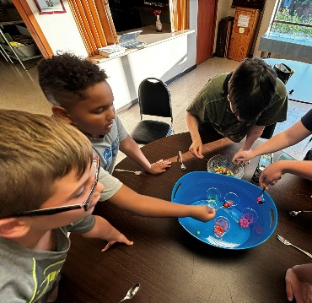 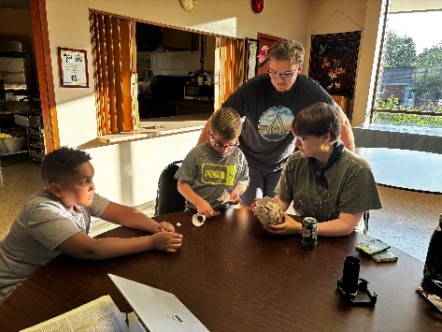

**Trivia Night**

August 10th marked Paulin's first Trivia Night, emceed by John Garswood.  It proved to be a hugely popular FUNraiser, with about 45 people in attendance, in eight or nine teams, competing for truly amazing prizes, in several rounds of a variety of trivia questions, including TV theme songs, pop culture, history, geography, sports, literature, and of course, Bible facts!  The winning team named Audrey Landon their MVP, and proved definitively that a multigenerational team is the way to go for success!  (Rumour has it that Justin Golab intends to defect to that team next time...).  A really fun night, and it looks like we'll be doing it again once in a while!

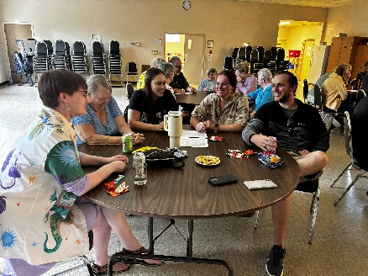

Editors Note: Another rumor has it that Paul Anka may show up!

**Upcoming Events:**

World Communion Sunday – October 6, 2024

Thanksgiving Sunday – October 13, 2024

Trunk or Treat – October 27, 2024

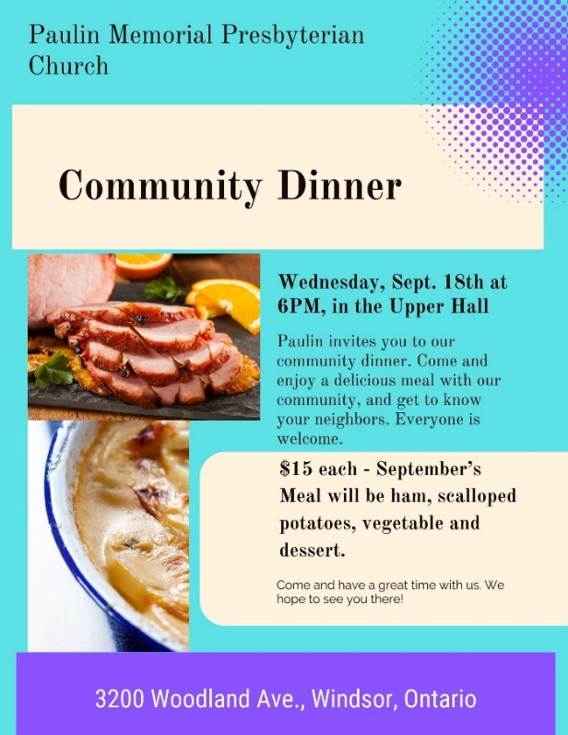  MG

**Men’s Breakfast**

**Sat. Sept. 21st 2024**

**9:00 am**

**Paulin Memorial**

**Upper Hall**

Please sign up on Men’s Breakfast sheet in Narthex